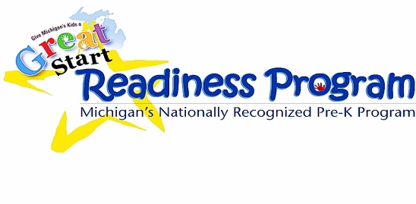

Sign-up your 4 year old

**TODAY**!!

*\*These materials were developed under a grant awarded by the Michigan Department of Education\**

**Great Start Readiness Program** *and* **Head Start : 2020-2021 year**

***Our Preschool Partners:***

ABC Academy

*(various locations,*

*including: Dibble & Hunt Elementary)*

Columbia Schools

Community Action Agency

Concord Schools *(ABC Academy)*

The daVinci Institute

Early Impressions

*(E. Michigan Ave & Parma Elementary)*

East Jackson Schools *(Phoenix Academy)*

Grass Lake Schools

Hanover-Horton Schools *(Early Impressions)*

Jackson Public Schools *(CAA & ABC Academy)*

Michigan Center Schools

Napoleon – Pirate’s Cove

Northwest Schools

Phoenix Child Care & Academy

Springport Schools

Vandercook Lake Schools

Western Schools

**…then your child qualifies for FREE, high-quality preschool!**

**VISIT:** [**www.greatstartjackson.org**](http://www.greatstartjackson.org) **to sign up.**

***Have questions?* Call the preschool hotline at 517-768-5130**

### Does your family’s income fall in the chart below?...

### Family of 2 = $43,100 or less Family of 3 = $54,300 or less

### Family of 4 = $65,500 or less Family of 5 = $76,700 or less

### Family of 6 = $87,900 or less Family of 7 = $99,100 or less

### *\*\*Higher income levels may be considered in some circumstances-apply to learn more\*\**

**www.greatstartjackson.org**

**Time to SIGN UP your 4 year old for**

**PRESCHOOL** SIGN-Up

www.greatstartjackson.org

#### Preschool Sign Up

www.greatstartjackson.org

#### Preschool Sign Up

www.greatstartjackson.org

#### Preschool Sign Up

www.greatstartjackson.org

#### Preschool Sign Up

www.greatstartjackson.org

#### Preschool Sign Up

www.greatstartjackson.org

#### Preschool Sign Up

www.greatstartjackson.org

#### Preschool Sign Up

www.greatstartjackson.org

www.greatstartjackson.org

#### Preschool Sign Up

#### Preschool Sign Up