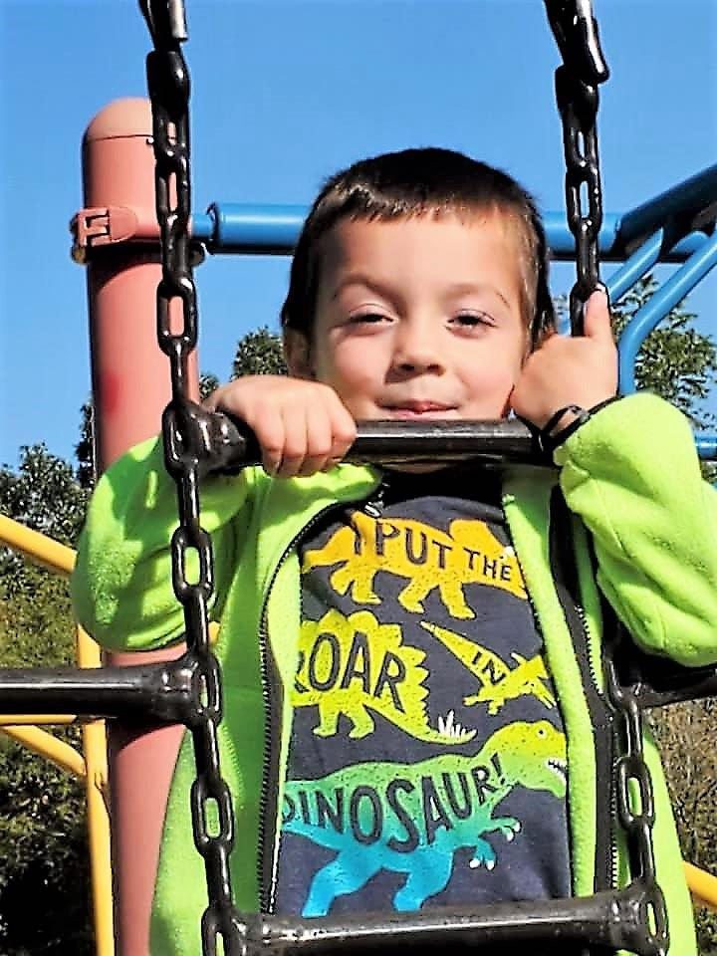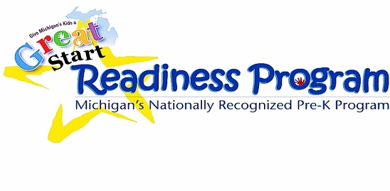

**www.greatstartjackson.org**

All 4-Year-Olds Now Qualify!!

Sign-up your 4 year old

**TODAY**!!

*\*These materials were developed under a grant awarded by the Michigan Department of Education\**

**Great Start Readiness Program** *and* **Head Start : 2020-2021 year**

***Our Preschool Partners:***

ABC Academy

*(various locations,*

*including: Dibble & Hunt Elementary)*

Columbia Schools

Community Action Agency

Concord Schools *(ABC Academy)*

The daVinci Institute

Early Impressions

*(E. Michigan Ave & Parma Elementary)*

East Jackson Schools *(Phoenix Academy)*

Grass Lake Schools

Hanover-Horton Schools *(Early Impressions)*

Jackson Public Schools *(CAA & ABC Academy)*

Michigan Center Schools

Napoleon – Pirate’s Cove

Northwest Schools

Phoenix Child Care & Academy

Springport Schools

Vandercook Lake Schools

Western Schools

**VISIT:** [**www.greatstartjackson.org**](http://www.greatstartjackson.org) **to sign up.**

***Have questions?* Call the preschool hotline at 517-768-5130**

### *The income cap for families to enroll children into our Great Start Readiness Preschool programs has been lifted for this school year! This means that if you thought you may not qualify, you now will if you have a child turning 4 by December 1st!*

### Great News!

**Time to SIGN UP your 4 year old for**

www.greatstartjackson.org

#### Preschool Sign Up

www.greatstartjackson.org

#### Preschool Sign Up

www.greatstartjackson.org

#### Preschool Sign Up

www.greatstartjackson.org

#### Preschool Sign Up

www.greatstartjackson.org

#### Preschool Sign Up

www.greatstartjackson.org

#### Preschool Sign Up

www.greatstartjackson.org

#### Preschool Sign Up

www.greatstartjackson.org

www.greatstartjackson.org

#### Preschool Sign Up

#### Preschool Sign Up